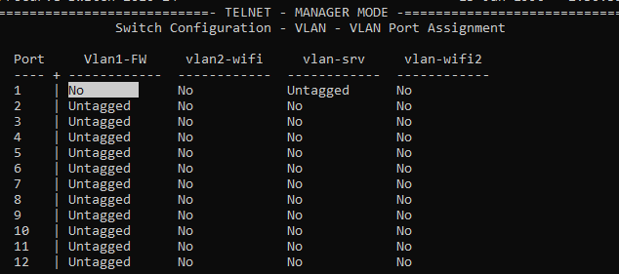

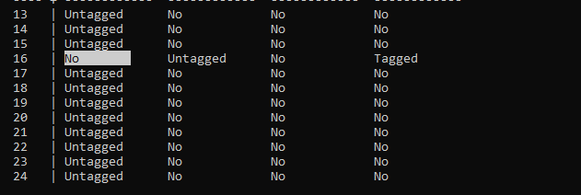

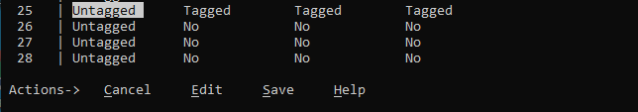

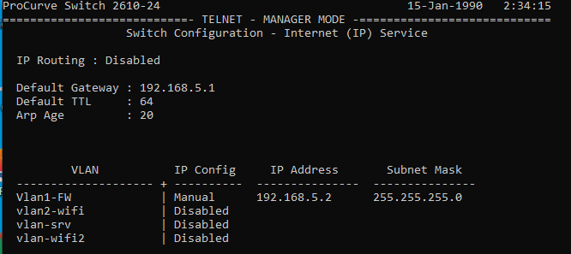

25 g0/0 < FW (transport vlans _ tagged )

1 fa1 > cq56 www server (vlan-srv sur l’interface _ untagged)

16 fa16 > wifi borne ( vlan2-wifi sur l’interface _ untagged)

(vlan-wifi2 transport sur l’interface _ tagged)